Project Planning Phase
Project Planning Template
Date | 24 September 2026
Team ID | SWTID-2026-7356
Project Name | AI StudyBuddy
Maximum Marks | 5 Marks
Product Backlog, Sprint Schedule, and Estimation
Sprint | Functional Requirement (Epic) | User Story Number | User Story / Task | Story Points | Priority | Team Members
Sprint-1 | User Authentication | USN-1 | As a user, I can sign up for the application with my name, email and password. | 2 | High | Davasi P
Sprint-1 | User Authentication | USN-2 | As a user, I can sign in to the application with my registered email and password. | 2 | High | Davasi P
Sprint-1 | User Authentication | USN-3 | As an authenticated user, I can use JWT access and refresh tokens to reach protected features. | 2 | High | Davasi P
Sprint-2 | Study Material Management | USN-4 | As a student, I can upload study materials (.txt, .md or .pdf, up to 5 MB) for AI processing. | 3 | High | Himalayan S
Sprint-2 | Study Material Management | USN-5 | As a student, I can list, view and delete the study materials I have uploaded. | 2 | High | Himalayan S
Sprint-2 | AI Summary | USN-6 | As a student, I can create a concise AI summary from my study material. | 3 | High | Sanjay Raman M
Sprint-3 | AI Flashcards | USN-7 | As a student, I can create AI-powered flashcards from my study material. | 2 | High | Sanjay Raman M
Sprint-3 | AI Quiz | USN-8 | As a student, I can create multiple-choice quizzes from my study material. | 3 | High | Hariharan E
Sprint-3 | AI Study Plan | USN-9 | As a student, I can create a personalised study plan from my goal, daily hours and number of days. | 3 | High | Bharath M
Sprint-4 | Admin Management | USN-10 | As an administrator, I can view and delete registered users and check system statistics. | 2 | Medium | Bharath M
Sprint-4 | Learning Resources | USN-11 | As a student, I can open my previously generated summaries, flashcards, quizzes and study plans. | 2 | Medium | Hariharan E
Sprint-4 | Database Management | USN-12 | As a system, I can securely store users, study materials and AI-generated resources in MongoDB. | 2 | Medium | Sanjay Raman M
Project Tracker, Velocity & Burndown Chart
Sprint | Total Story Points | Duration | Sprint Start Date | Sprint End Date (Planned) | Story Points Completed | Sprint Release Date (Actual)
Sprint-1 | 6 | 1 Day | 20-09-2026 | 21-09-2026 | 6 | 21-09-2026
Sprint-2 | 8 | 1 Day | 21-09-2026 | 22-09-2026 | 8 | 22-09-2026
Sprint-3 | 8 | 2 Days | 22-09-2026 | 23-09-2026 | 8 | 24-09-2026
Sprint-4 | 6 | 2 Days | 23-09-2026 | 24-09-2026 | 6 | 25-09-2026
Total Story Points: 28
Velocity
Assuming a total sprint duration of 6 days and 28 story points completed across 4 sprints:
Average Velocity = Total Story Points ÷ Total Sprint Days
Average Velocity = 28 ÷ 6 = 4.67 story points/day
Burndown Chart & Sprint Velocity
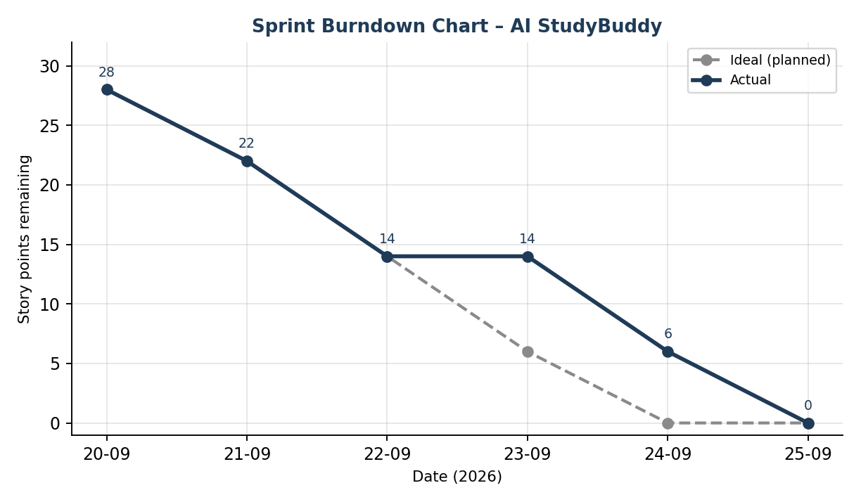 | 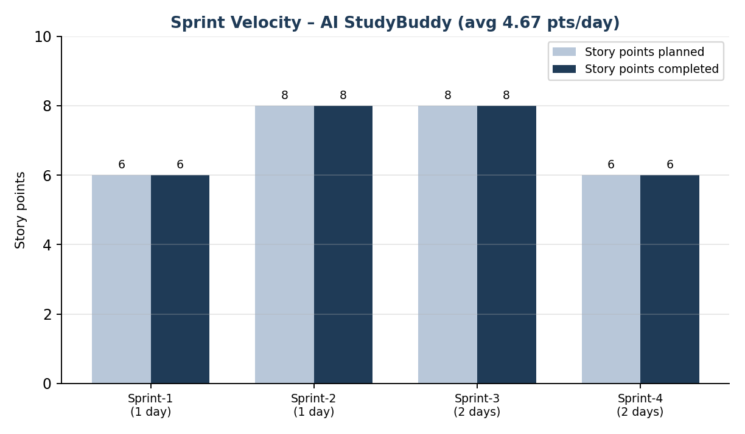
This plan follows the documented AI StudyBuddy features, including authentication, material management, AI-generated summaries, flashcards, quizzes and study plans, and administrative operations.

